PURPOSE
The Stories of Change template helps capturing and sharing learning from programme activities with a human-interest angle, focusing on how EGP’s work enabled change in people’s perspectives and attitudes. It focuses on capturing the experiences of EGP stakeholders, with special attention to local communities, women, youth, government partners and decisionmakers.

TARGET AUDIENCES
- EGP Focal Points, LEKM Focal Points and key stakeholders in programme countries (Argentina, Ecuador, Colombia, Kenya, Kyrgyzstan, Liberia, Mongolia, Namibia, Peru, and Zambia).
- Donors/Swedish Government Counterparts (SEPA, Sida).
- UNDP Country Offices and Global Policy Network (GPN).
- Future prospective donors, with a focus on Embassies in EGP programme countries.

WHO SHOULD USE THE TEMPLATE?
The template seeks to provide guidance to EGP and Learning Focal Points in programme countries. Focal Points are encouraged to use the template in consultation with the CO Communications Officers and/or Country Office Team members.

When using the form, interviews need to be carried out with key EGP stakeholders, including local communities, women, youth, and civil society organizations participating in EGP-supported work/activities.

TOP TIPS
- Remember that a good story incorporates information on context and factual background answering the basic journalistic questions of: Who, What, Where, When, How and most importantly, Why?
- Start with an informative headline and an introductory paragraph summarizing the details of story that immediately captures the attention of the reader.
- Make sure all information in the story has been verified. Include links to support facts and figures. Prioritize UNDP, UN, and other credible sources from your CO country partners and key stakeholders.

How to submit YOUR story OF CHANGE

The template will help you collect information for your Story of Change. You should submit the story to the EGP core team once it incorporates all elements outlined in the template.

- What is the issue that you are capturing? What is this story about? Why is this issue important for achieving EGP outcomes in your country?
In 1-2 paragraphs, describe the issue that you want to bring attention to, by explaining its relevance to your country’s mining governance context and challenges. You can also explain how the problem contributes to improved environmental and human rights protection, and its links to the overall development scenario of your country.
- Make sure there is a reason EGP is telling this story (focusing on the value-added by EGP’s intervention, key lessons learned etc.). Remember that whether your content is an article, blog post or feature story, compelling content delivers what your audience wants and needs - while attracting and maintaining their attention.

Length: 200 words

- Insert a quote by an EGP stakeholder in your country.
Quotes capture the experiences of EGP stakeholders and partners. This includes key government decision makers, CSOs and local community members who are part of the solution to mining governance challenges and engaged in EGP co-creation, and implementation on the ground.

- When preparing your interview questions, try to find the best way to portray the programme’s effects on people’s lives. Remember to always look for the human-interest angle. Human-centred stories are the best way to communicate the programme’s impact to external audiences. No matter how complex the issue, we want to tell the story in a conversational and interesting way, focusing on how people’s lives have been changed by EGP’s work.

Length: 100-150 words

- Describe EGP contributions to addressing the problem
Insert a paragraph on the EGP’s role in solving the problem addressed in the story, with a focus on how the programme has contributed to improved environmental and human rights protection in mining governance. You can respond to the following key questions: (i) What has worked?; (ii) Why?; and (iii) What are the impacts?

- Invest time in this paragraph as you only have, at most, a few sentences to draw the reader into the programme’s role and contributions.

Length: 150 words

- Insert the second quote by a mining governance stakeholder here.
Insert your second quote here. Don’t forget to feature at least one quote by a community member, woman, young person, civil society organization participating in EGP’s work in your country, if possible.

Length: 100 words

Check out a good example by the EGP team in Argentina here.

- What are the next steps? What do you look forward to?
Use this section to discuss future perspectives for addressing the issue addressed in the article and future plans of the programme (i.e., programme plans in 2022-2023). You can respond to the questions: (i) What are the future challenges? (ii) How can we held address barriers to progress? and (iii) What are we learning that can be critical for future work around this issue?

Length: 150 words

- Photos, links, and any other visual and digital assets
Please provide high quality photos/video footage and/or weblinks that can bring your story to life, with a focus on work in the field, with communities and civil society organizations. Please upload your photos into a SharePoint, Dropbox or Google Drive folder and include the link here <________________________________>. If this is not possible, send the photos as an attachment in your e-mail.

- Credits format: @UNDP (country office)/name of the photographer.
- Captions: Please try to provide the names, profession, ages of any people photographed, and short details about the story, including where it was taken (name of the village/district/city and province).
- Authorization: Please make sure that you have obtained consent from the photographed people, using the UNDP Terms of Authorization

HOW TO SUBMIT THE TEMPLATE?

Step 1 – Send the fully completed form to Daniel and Francisco at Daniel.schatz@undp.org and contact.egp@undp.org. Please attach any supporting documentation, concept notes, and related materials.
Step 2 – We will review your draft and make possible changes.
Step 3 – We will send back the updated draft for your approval. The final product is then approved by the EGP Management Team.
Step 4 – Once cleared, the story will be published on the EGP public website, on EGP’s SparkBlue page and uploaded into the EGP Learning Channel on Teams. The story should also be published on your CO public website.
Step 4 – The story will be promoted on social media, via UNDP Sweden and Swedish EPA accounts. Your CO should also promote it.

ANNEX 1: GOOD EXAMPLES OF STORIES OF CHANGE
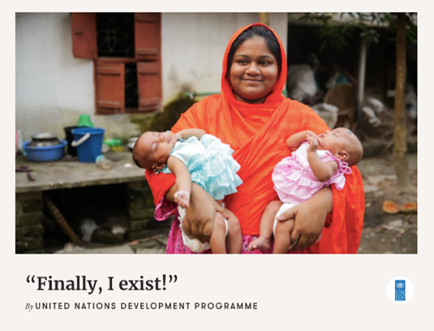 | “Finally, I exist”, published by UNDP on November 10, 2021
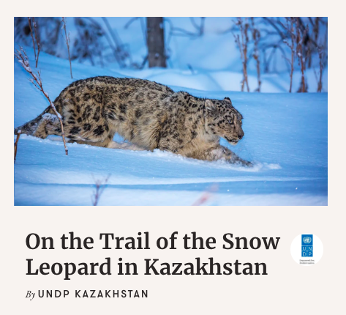 | On the Trail of the Snow Leopard in Kazakhstan, published by UNDP Kazakhstan on October 22, 2021
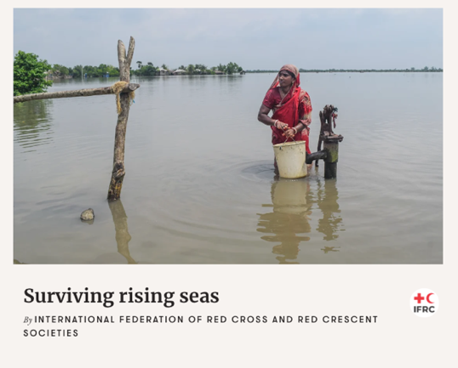 | Surviving Rising Seas, published by the International Federation of Red Cross on November 9, 2021

More examples:
- Stories prepared by the Young Environmental Journalists
- Feature Stories selected by Exposure

ANNEX 2: UNDP PHOTO GUIDELINES

Photos of the results of UNDP’s work are integral to telling UNDP stories. Elements of a good photo essay convey a story and a message through un-posed environmental portraits, posed portraits (if appropriate), project details, indoor and outdoor settings, landscapes, wide shots, action, interaction, and daily life.

Technical Specifications:
- Camera position: Primarily shoot horizontal; shoot vertical when appropriate.
- File Format and Resolution: Always shoot RAW. Photos must be delivered in high-res JPEG format, preferably at a minimum pixel dimension of 2800 x 4200, 10MB at 300 dpi.
- Retouching: Make light adjustments to correct exposure, contrast, sharpness, etc. Avoid vignettes and over or under saturating.
- Perspectives: photograph various and unique viewpoints, including aerial when possible. Primarily shoot horizontal; shoot vertical when appropriate. Focus on framing your composition.
- People: Always be respectful when photographing people; always receive informed consent to photograph them and represent them with dignity and respect. Receive permission of parents or guardians to photograph children. Please use the standard UNDP Term of Authorization for the Use of Personal Image; the EGP Global Team can help you with this.

- Captions: Please provide full and final captions at time of submission in the file metadata: include the names, profession, and ages of people photographed, and details about the story. Explain what we are viewing and the context: Where, When, Who, What, and Why. Include the donor, the project code, and photo credit. Example:

15 March 2016 – Jalabad, Afghanistan. Doctor Khalid, 42, studies malaria samples.
80% of Afghanistan's malaria cases are in the east, where humidity is a breeding ground for mosquitoes. The Afghan Ministry of Public Health, UNDP and the Global Fund are distributing 2.7 million bed nets and equipping 14,500 clinics with rapid diagnostic test kits and anti-malaria drugs. Donor: Govt of Japan. Project code: 00076393. Photo: UNDP Afghanistan/Omer Sadaat.
- Crediting: Include it in the caption (as above) and in the specified field in the metadata as Photo: UNDP (hiring country office)/photographer’s name. Example:

Photo: UNDP Afghanistan/Omer Sadaat

